Background
Standard Steel and Concrete Bridges in Missouri
- For most of the last two decades the belief around the bridge industry in the U.S. was that concrete girder bridges were cheaper to construct than equivalent steel girder bridges. This belief was common for spans less than 120 feet.
- This myth was perpetuated because steel was often used on more complex, expensive bridges, and those complex bridges increased the initial average cost per square foot of steel bridges.
- Given budget constraints, MoDOT decided whether to construct a steel or concrete bridge based only on initial cost.
- Since May of 2017, DeLong’s, Inc. representatives have worked closely with MoDOT to review historical cost data regarding the initial cost of comparable structures, standard steel and concrete bridges.
- Research showed the initial average cost per square foot of standard steel and concrete bridges was comparable.

Recent Actions
Based on the actual cost data, in December 2017, MoDOT updated the MoDOT Engineering Policy Guide to specify steel and concrete bridges as the same initial cost.
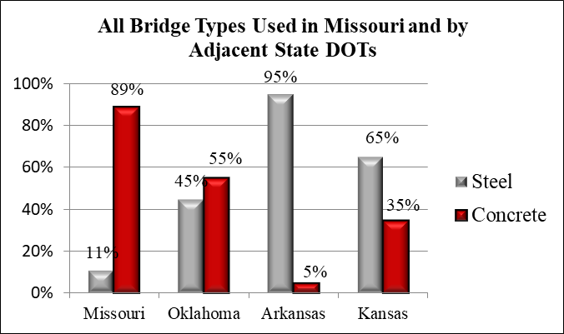
From January 2018 through June 2018, MoDOT has let 2 standard steel bridges totaling $663,000 and 61 standard concrete bridges totaling $50,250,000.
Bridge Types Used in Adjacent States & Missouri Cities and Counties
- Some surrounding states use significantly more steel for bridges than Missouri.
- Missouri cities and counties have built 59 standard steel bridges compared to MoDOT’s two standard steel bridges from January 2014 through June 2018.
* Estimates based on current feedback from State DOT representatives.

Total Standard Steel and Concrete Bridges let by MoDOT between January 2014 and June 2018:
 | Total Spent | Total Number | Percentage | Average Cost Per Sq. Ft.
Steel | $663,389 | 2 | 1% | $90
Concrete | $166,965,592 | 237 | 99% | $102

Other Advantages of Steel in Addition to Initial Cost
  - Adaptability and Repairability – Steel bridges can easily be widened, lengthened, strengthened, re-decked, and modified to accommodate future needs, and sections can be repaired quickly and easily.
  - Renewability – Steel is the most recycled material on earth. Recycled content of structural steel is over 90%.
  - Efficiency – Steel’s span-to-depth ratio is more efficient than concrete’s, reducing fill dirt required at approaches.
  - Constructability – Steel girders are lighter than concrete girders for the same span, which enables the use of smaller capacity cranes.
  - Reusability – Old beams/girders can be used for new bridges, as falsework support by contractors, or recycled.

