Employee Instructions for UKG Timekeeping (Hourly Office)

*Important* In UKG Employee Self-Service (ESS) and timekeeping are in one unified system, unlike our previous system. This means your username and password will always be the same for both.

Logging Time in UKG
- The system is internet based – the website will be saved on all timeclocks.

- Getting logged in:
  - Login link: https://secure6.saashr.com/ta/6150104.clock
    - Bookmark as a favorite
    - If you need help, contact IT or HR
  - You will receive an email with log-in info
    - If you have an @delongsinc.com email, it will come there.
    - Otherwise, it will go to your payroll email.

- Your Employee ID and password is unique to you and must not be shared.
  - Employee ID: Your clock number
  - Password:
    - Will be set to the default: last 4 of your SSN.
    - The first time you log in, the system will require you to change this.
      - Your password must be:
        - 8 characters long
        - Upper and lowercase
        - At least 1 number
        - At least 1 special character
    - You can set this to whatever you like
    - Example:
      - If your name is John Doe, and SSN is: 123-45-6789
      - Doe6789!
    - Or – you can just add a special character (like !) to the end of your current password.

- Clocking In
  - Enter your Employee ID
  - Enter your password
    - Click on “Punch In / Transfer” if clocking into a direct labor job.
    - Click on “Punch In” if clocking into a default/indirect labor job.
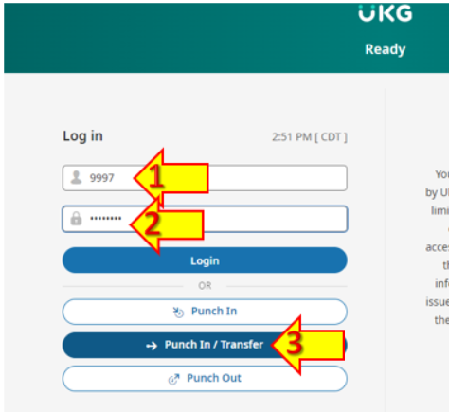

    - Important change – Punch In & Punch Out are now different buttons to help with confusion over which is needed.
    - If you will be clocking into different job numbers and pay codes, you must use the “TRANSFER” button rather than “Punch”

  - TRANSFER will take you to the next login screen:
    - Jobs & Functions are combined on this screen.
    - Only functions that actually exist on a job will be available options
      - E.g. If there are no Knee Braces on a job, that will not be an option to pick.

    - Type in the job you are working on, and hit “Enter”
      - Example: 21-104
    - Then click on the flag next to the correct function:
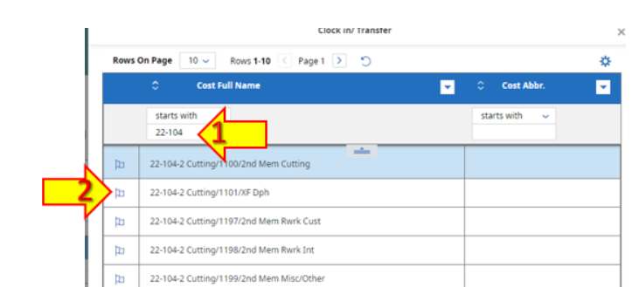

- This change is to make it easier to get the correct job/function pairings tied to work hours.
- This information is critical to have better job bidding and better understand labor costing.
- Accuracy here is critical to our ability to move forward with projects like production-based bonuses.

    - You will get a message saying the transfer was successful:
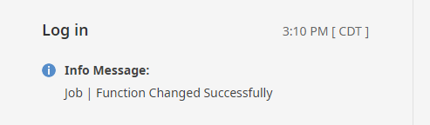

  - Indirect Labor/those with a default job/function can follow the same steps but choose the “Punch In” button instead.
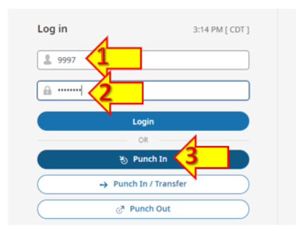
  - The system is now ready for the next employee. You do not need to log out.

- Changing Job# or Function
  - Repeat these steps to switch between jobs/functions.

- Clocking Out for lunch or end of day
  - Enter your Employee ID
  - Enter your password
  - Click on “Punch Out”

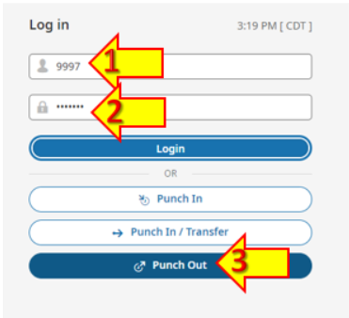

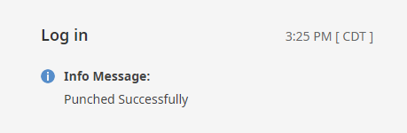
  - You will get a confirmation message:

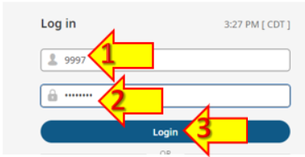
Requesting Time Off
- Log into UKG
  - Enter your Employee ID
  - Enter your password
  - Click on “Login”

- Use the “My Accrual Balances” widget.
- 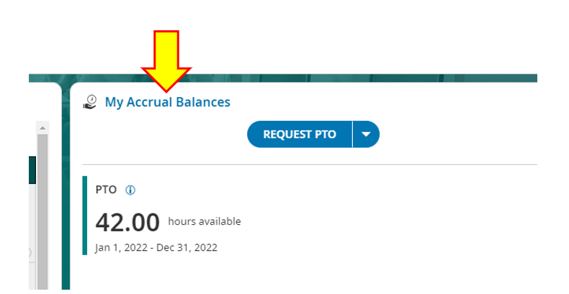
  - You will be able to see all of your available leave time in this window.
    - Balances in UKG should be used NOT the balances on the paystubs.
    - Because UKG is real-time, and pay stubs are at least 1 week behind, the UKG balances will be more accurate.
  - To request PTO, click on the left side of the button.
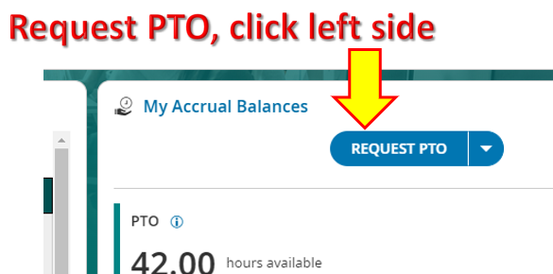

    - If you picked PTO on accident, you can change it from the next screen:
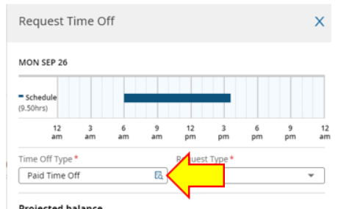
  - To request any other type of leave, click on the right side of the button:
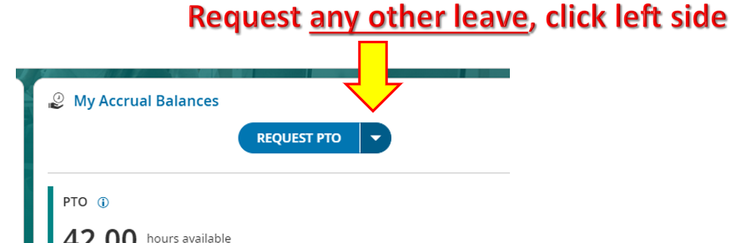
  - Use the drop-down menu to pick the other type of leave:
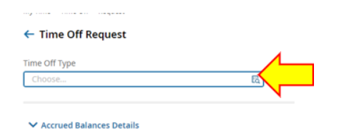
  - Click the button next to the type of leave you want to request:
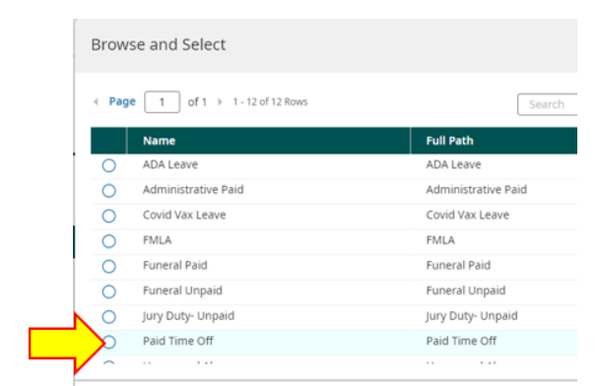
  - Pick the correct “Request Type” from the drop-down menu:
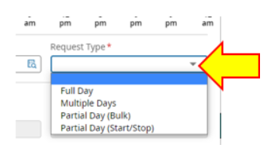
      - Full day = entire shift
      - Multiple days = at least 2 consecutive days
      - Partial day (bulk) = lump sum amount [e.g. “4 hours”]
      - Partial day (start/stop) = from time to time [e.g. from 07:00 – 07:06]

  - Enter the date of the leave:
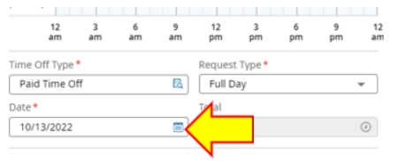

  - Clicking on “Calculate” will tell you the before and after balances of your leave on that date:
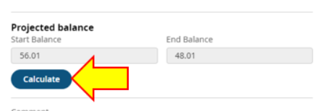
  - Entering a comment about the request is optional, but helpful.
    - If you are doing a PTO Cash out – please enter that here!!
  - Then click “Submit Request”
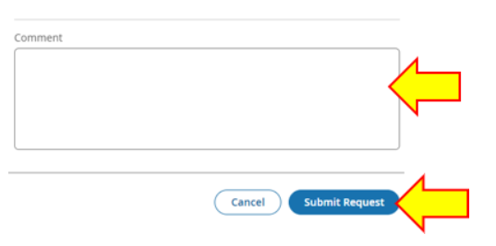

  - You will get a confirmation message:
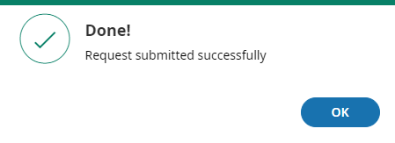

  - IF ON A SHARED COMPUTER - MAKE SURE TO LOG OUT WHEN YOU ARE DONE!
    - Click on your initials/picture in the upper right corner.
    - Click on log out

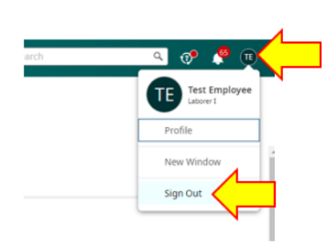

Approving Your Timecard

Each employee will be required to approve their own timecard EACH WEEK before it is approved by the supervisor.
- For First Shift: This should be done by first break on Monday mornings for the previous week’s time.
- For Second Shift: This should be done by lunch on Mondays.
Employees will be responsible for the accuracy of these timecards.

- Log into UKG
  - Enter your Employee ID
  - Enter your password
  - Click on “Login”

- Click on the link for “My Timesheet”
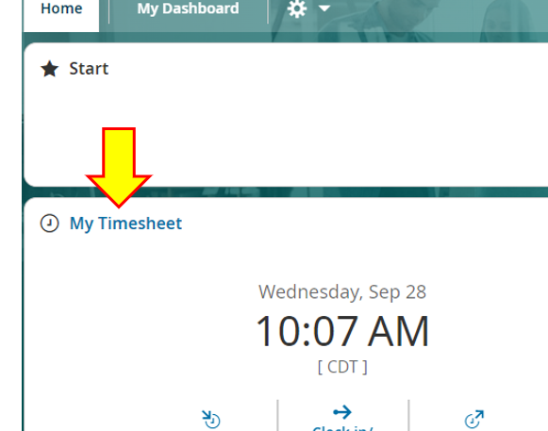
  - This view will always default to the current weekly pay period.
  - Click the back arrow to see the previous week:
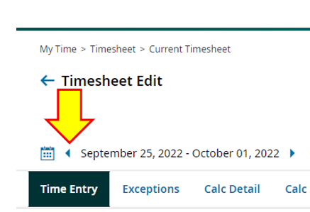

- Review timecard for errors:
  - MOST IMPORTANT: MAKE SURE ALL HOURS WORKED ARE RECORDED!
    - Look at the daily totals to make sure all your worked hours are entered.
    - Make sure there are no missed punches on your timecard.
    - These need to be fixed BEFORE you submit your timecard.
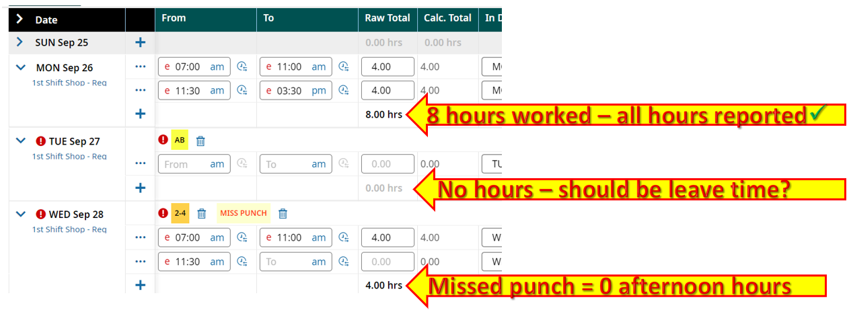

    - You will not be able to go back and correct these missed punches – notify your supervisor.
      - Click on “Change Request” at the top of the screen
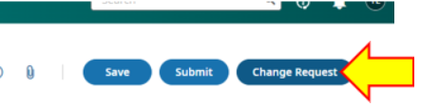
    - Choose the correct change type from the drop-down menu
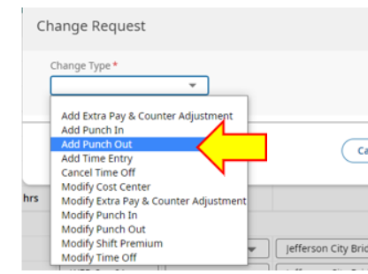

      - Enter the date
      - Enter the out time
      - Comment is optional, but helpful
      - Then click “Submit Changes.”
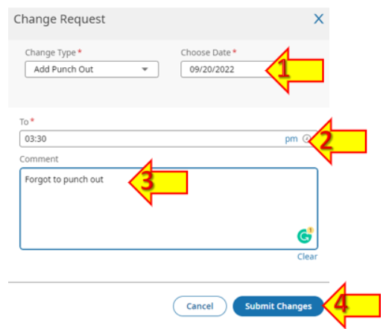

  - You will have to enter leave requests to avoid points in the other situations.
    - These can be submitted right from the timecard screen!
    - Click on the ellipsis (three dots) in the upper right corner
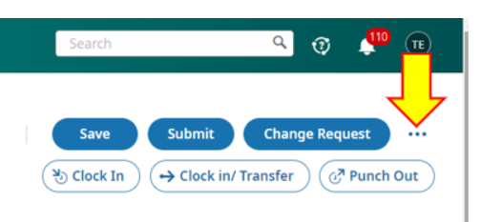
    - Select “Request Time Off” from the drop down menu.
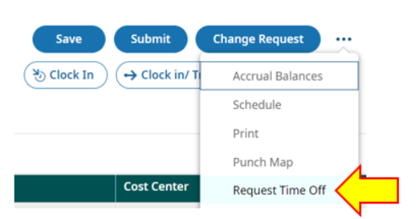
    - From this point, the steps look the same as the instructions above under “Request Leave Time”
  - Your submitted corrections will not show on your timesheet until approved by your supervisor.
    - Ask him/her to approve leave request/corrections.
    - Then log back in to ensure timesheet is accurate before submitting your time.

  - Next, look at your Job/Function column.
    - Since job/function are paired, you won’t have to check that anymore.
    - You do need to make sure the correct job/function was selected.
    - The ONLY time it is okay for this to be blank is if it is on a leave line. Any worked hours MUST have a job/function:
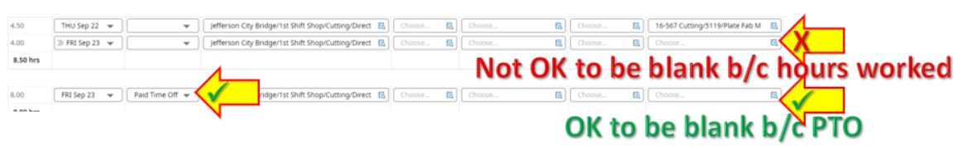
    - You CAN edit this part of your timecard. Make any necessary corrections.

  - Once all corrections are made and processed, click on Submit in the upper right corner.
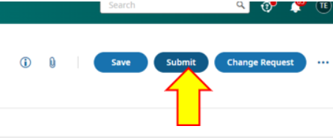

  - You will receive a notice that submitting will lock your timecard. Click Submit.
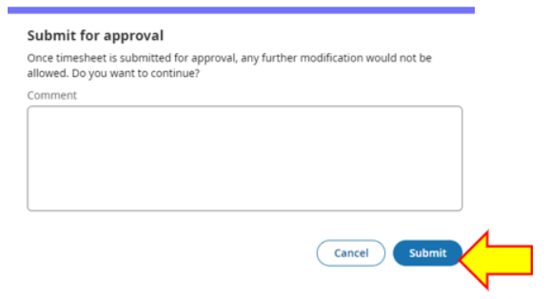
  - You will then get a confirmation statement to confirm:
    - You have accurately reported all hours worked/taken leave time.
    - You have reported any work-related injuries/incidents.
      - If you say “No” you will have to explain.
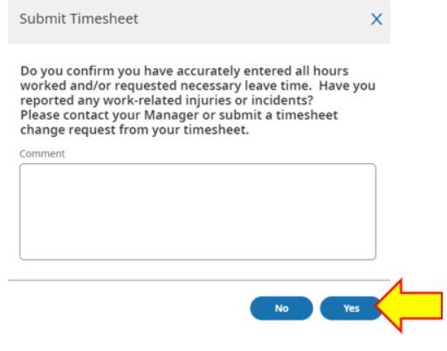
  - Timecard will now show “Submitted”
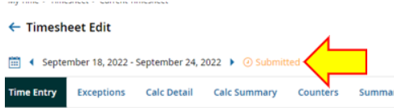

- IF USING A SHARED COMPUTER - MAKE SURE TO LOG OUT WHEN YOU ARE DONE!
  - Click on your initials/picture in the upper right corner.
  - Click on log out

