Supervisor Instructions for UKG Timekeeping

Unified Employee/Supervisor View

*Important* In UKG Employee Self-Service (ESS) and timekeeping are in one unified system, unlike our previous system. This means your username and password will always be the same for both.

This also means that you will no longer switch between an Employee view and a supervisor view. Both will exist at the same time.
- Any widget starting with “My” will be your own information.
  - The “My Timesheet” widget will be clocking in and out of your own timecard:
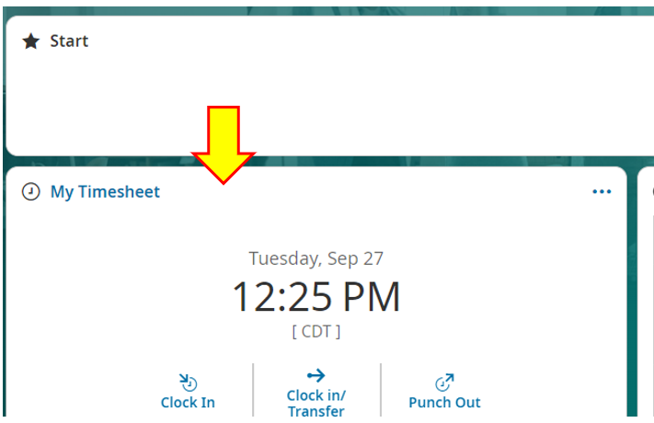
  - Scrolling down, the “Timecards Awaiting My Approval” will be your team’s timecards:
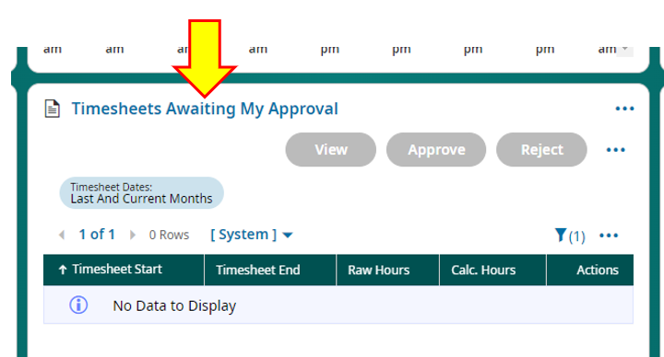
  - The actins you can take for yourself (request time off, etc.) and actions you take for your team are separated on the menu:
    - The menu icon is the three lines, and is in the upper left corner of the screen:
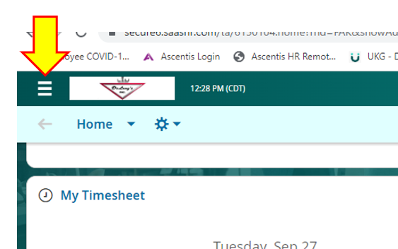

    - Once you click on the menu, your personal actions will be under the single person icon:
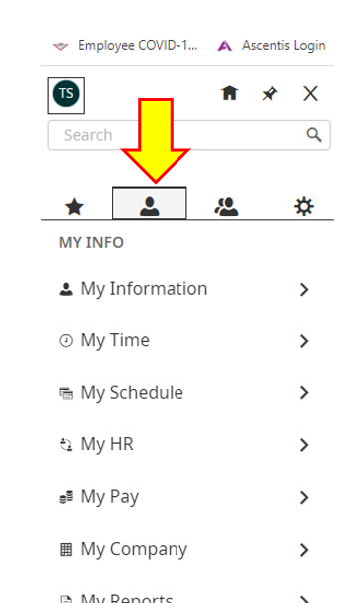
    - The actions for your team will be under the two-person icon:
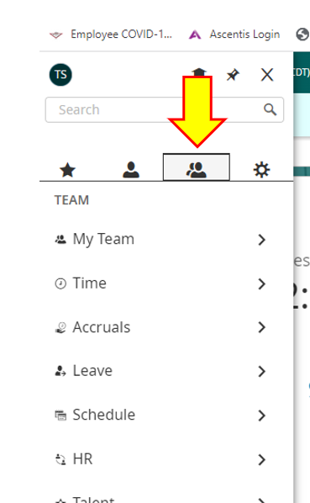

Logging Time in UKG

- The system is internet based.
  - Kiosk views will be saved on all timeclocks for the shop.
  - Supervisors will log in to the Employee Self-Service (ESS) view.
    - Website: https://secure6.saashr.com/ta/6150104.login?rnd=1664217689737&FS=
    - IT will be helping to save this as a favorite on all computers.

- Getting logged in
  - You will receive an email with log-in info
  - This will come to your @delongsinc.com email
  - This will also contain a link to the log-in screen.
    - It is recommended to save this as a favorite for easier access in the future.
    - IT and/or HR can help with that.

- Your Employee ID and password are unique to you and must not be shared.
  - Employee ID: Your clock number
  - Password:
    - Will be set to the default: last 4 of your SSN.
    - The first time you log in, the system will require you to change this.
    - Your password must be:
      - 8 characters long
      - Upper and lowercase
      - At least 1 number
      - At least 1 special character
    - You can set this to whatever you like
    - Example:
      - If your name is John Doe, and SSN is: 123-45-6789
      - Doe6789!

- Clocking In
  - Enter your Employee ID
  - Enter your password
  - Click on: Log In
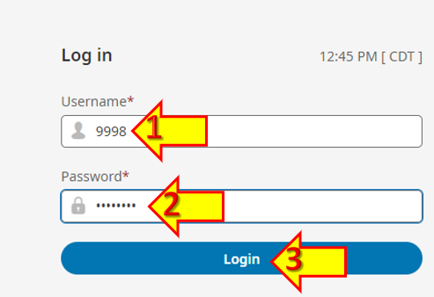
  - The first widget on your dashboard will be “My Timesheet”
    - If you are clocking into a default (like Supervision), just click on the “Clock In” button
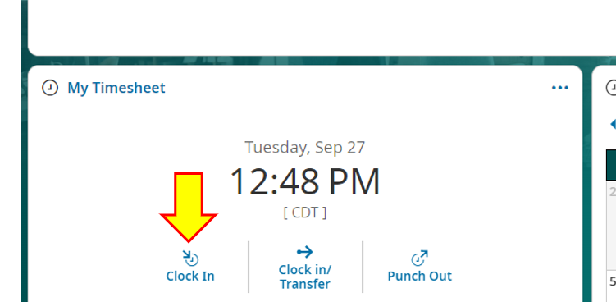
    - You will receive a confirmation message. Click “OK.”
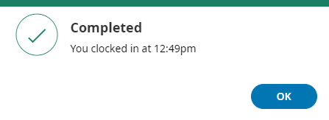
    - You can now see the “Clock In” button is grayed out, because you are already “In.”
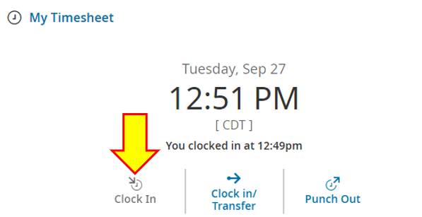

- *IMPORTANT!* If you are spending a significant amount of time on a direct labor function even as a supervisor, you need to transfer into a direct labor job/function.
  - Failing to do so can drastically skew our labor hours.

  - From the main dashboard (or any time kiosk in the shop), select “Clock in/Transfer”
    - Dashboard view:
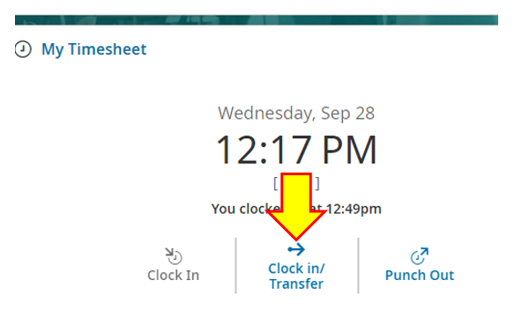

      - Click on the drop-down menu and then “browse”
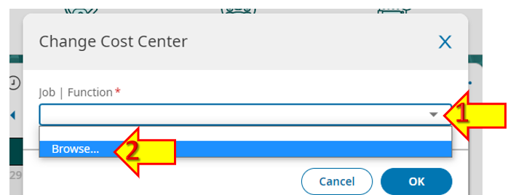
      - Jobs & Functions are now combined into a single selection.
      - This is to ensure that only functions which exist on a job are options to select.
      - Type in the job # and hit enter to jump to the functions available on that job.
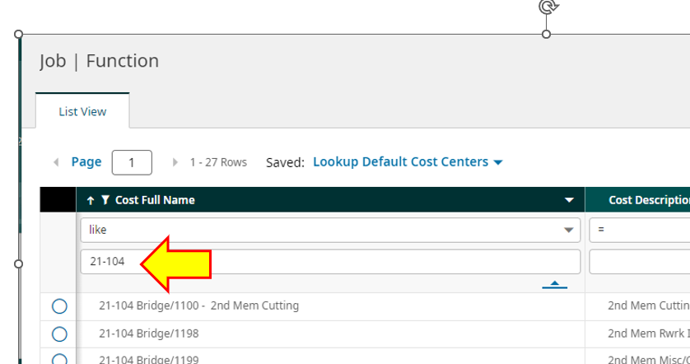
      - Click the button next to the correct function for that job:
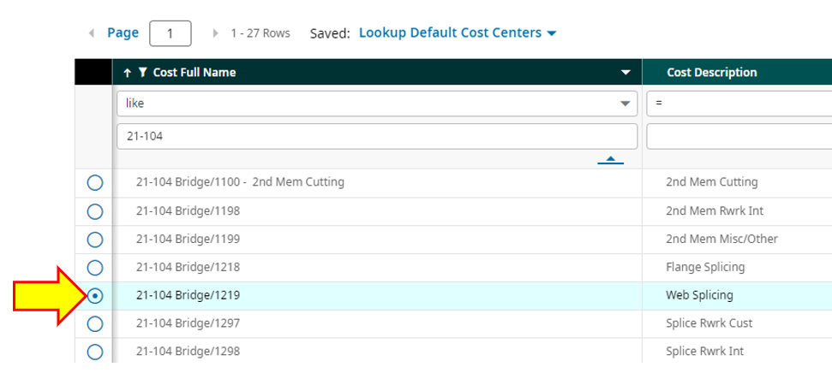
      - This will kick you back to the change screen, Click “OK.”
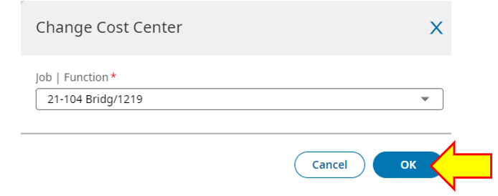

      - Fun fact – previously selected job/functions will show as you use the system:
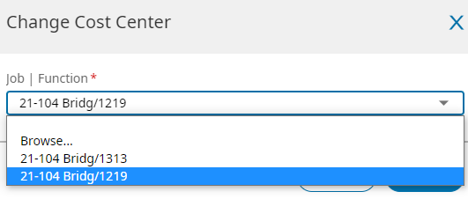
      - You will get a confirmation window. Click “OK.”
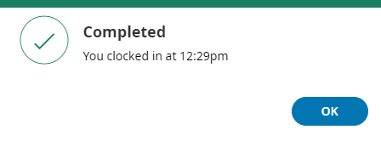

  - To clock out for lunch or the end of the day, simply click on the “Punch Out” button:
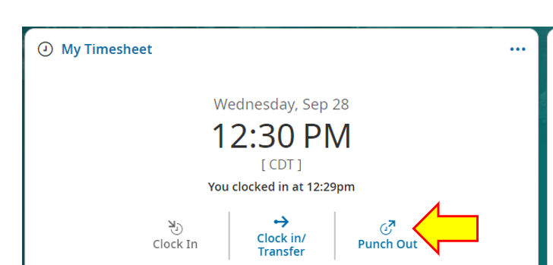
    - You will get a confirmation message. Click “OK”
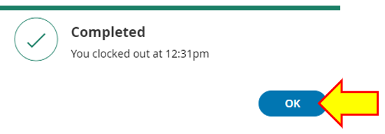

Requesting Time Off
- From your main dashboard, click on the “My Schedule/My Time Off” link
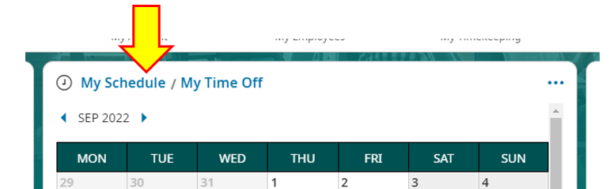

  - Your accrual balances will show on this screen.
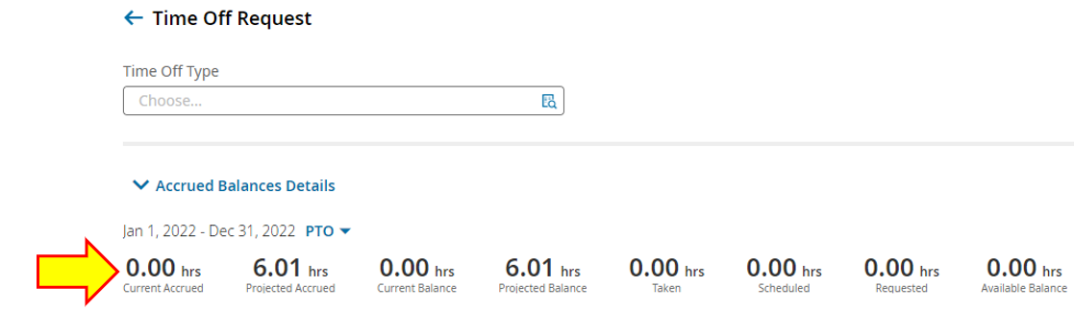
  - Use the drop-down menu to change accrual type view
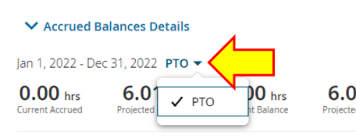
    - Balances in UKG should be used NOT the balances on the paystubs.
    - Because UKG is real-time, and pay stubs are at least 1 week behind, the UKG balances will be more accurate.
- Click on the drop-down menu to open the leave time options
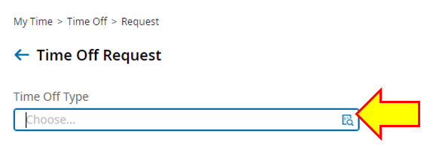
  - Click the button next to the type of leave you want to request
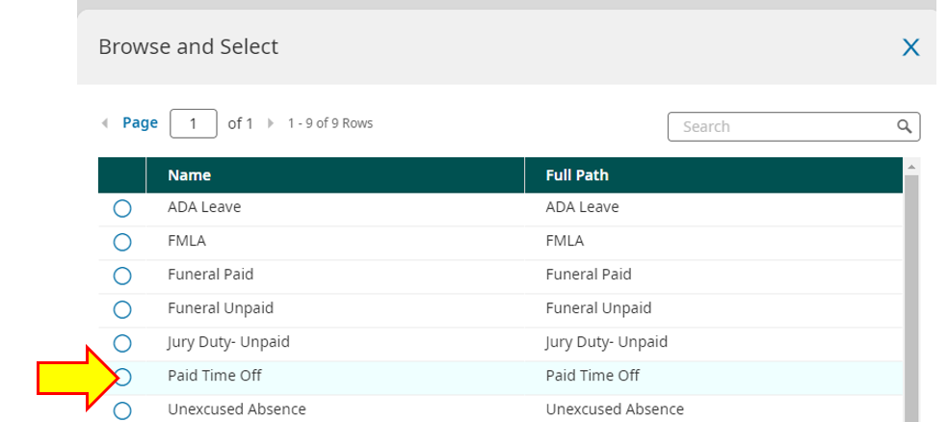
  - Click the button for “Start a Request”
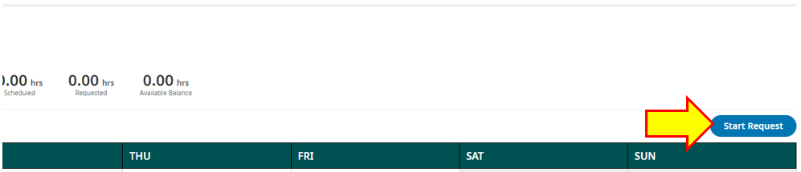

    - If you accidently picked the wrong type, you can change it here
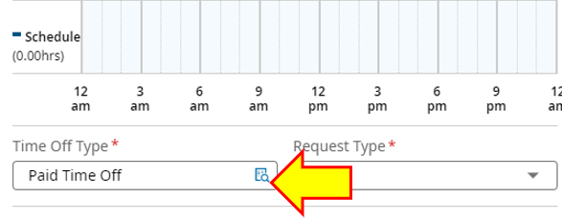
  - Pick the correct “Request Type” from the drop-down menu:
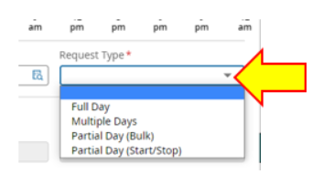
    - Full day = entire shift
    - Multiple days = at least 2 consecutive days
    - Partial day (bulk) = lump sum amount [e.g. “4 hours”]
    - Partial day (start/stop) = from time to time [e.g. from 07:00 – 07:06]

- Employees on point system should never use #3.
- For partial shifts ALWAYS use start/stop times.
- Since lunches are not auto-deducted, you must account for this in your request to avoid taking more time than necessary.
  - E.g., If you worked from 07:00 – 11:00 and then left for the day.
    - Enter your leave request from 11:30 – 15:30 to account for 30-minute lunch break.
    - This will correctly only charge you for 4 hours of PTO, rather than 4.5.

  - Enter the date of the leave:
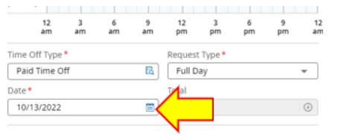

  - Clicking on “Calculate” will tell you the before and after balances of your leave on that date:
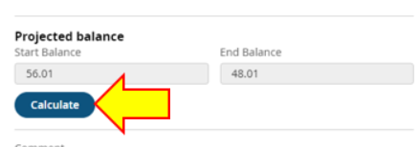
    - Entering a comment about the request is optional, but helpful.
      - If you are doing a PTO Cash out – please enter that here!!
  - Then click “Submit Request”
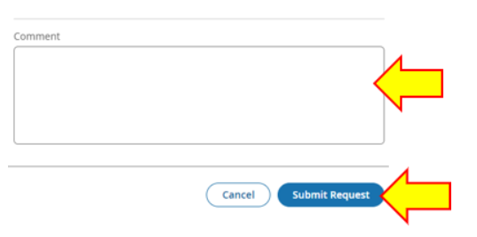
  - You will get a confirmation message:
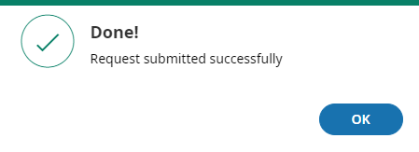

Approving Leave Requests
- All leave requests for the previous pay period must be approved before you review/approve any timecards.
- You will be notified of submitted leave requests by
  - Email to your work email.
    - This email will include a link to log in to the request.
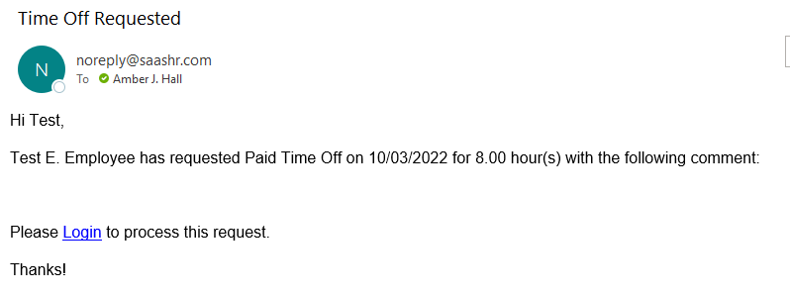
  - Notification in two places on your Dashboard.
    - My Mailbox:
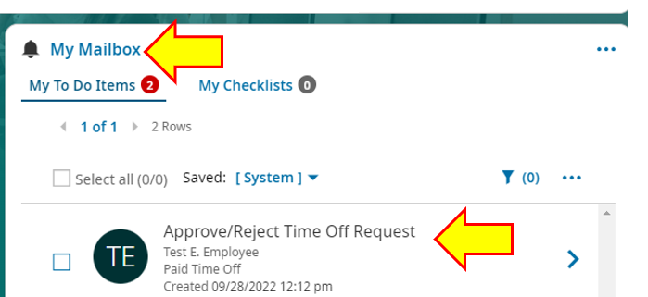
    - Time Off Awaiting My Approval:
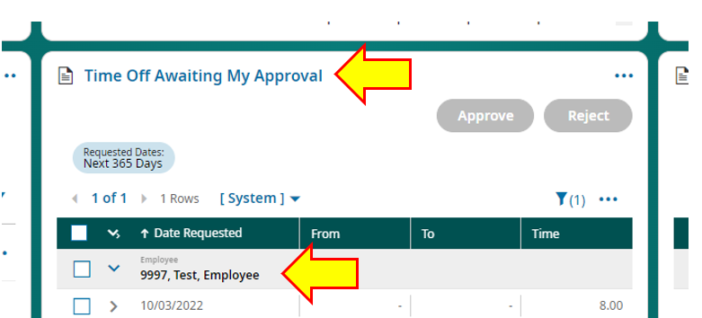
  - The Date and amount of the request of the request will show by default.
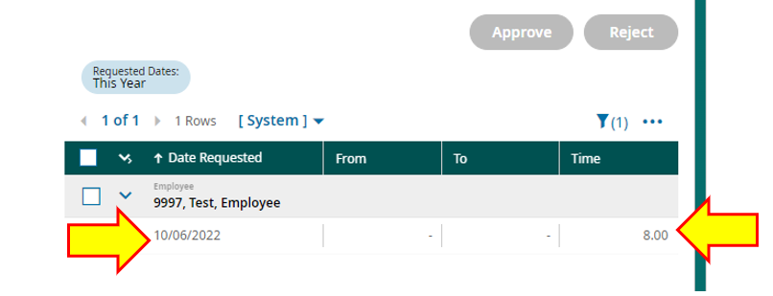
    - To see the type of leave requested and any comments, click on the arrow:
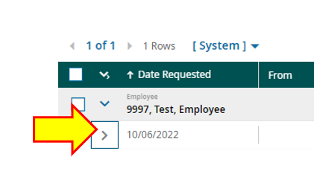
  - To process, check the box next to the date, then click “Approve” or “Reject”
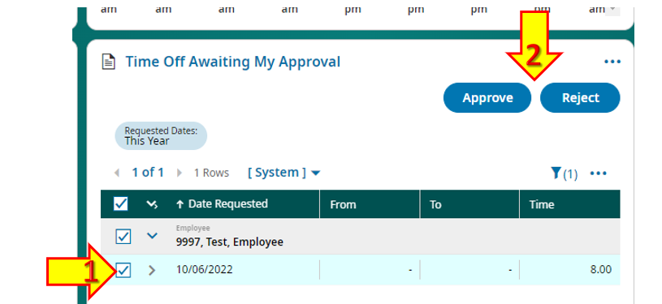
  - You will get a confirmation box.
    - Entering a comment is optional, but helpful if rejecting.
    - Click on “Approve”
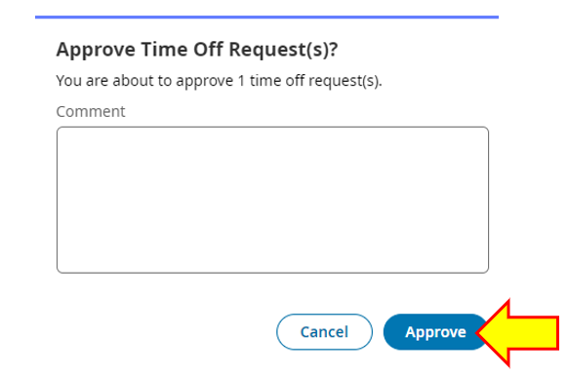

Reviewing Timecards

- Need some access to default view of open timecards

- Review and process any timecard change requests
- THIS MUST BE DONE BEFORE YOU REVIEW/APPROVE ANY TIMECARDS
  - These will show in your “My Mailbox”
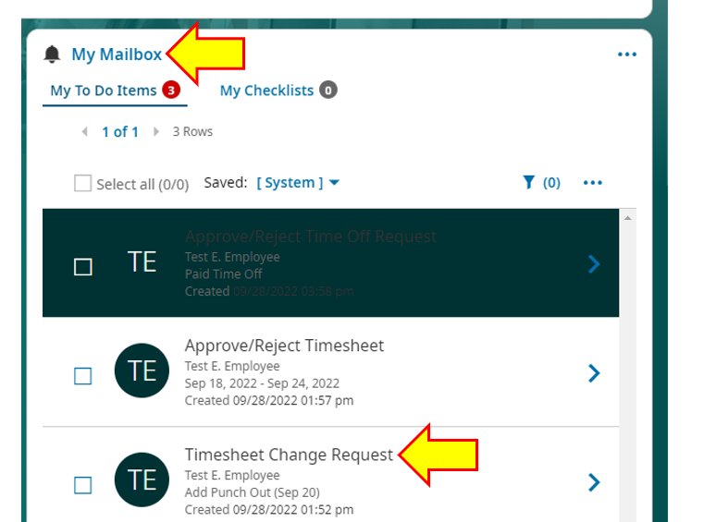
  - To see the request, click on the arrow
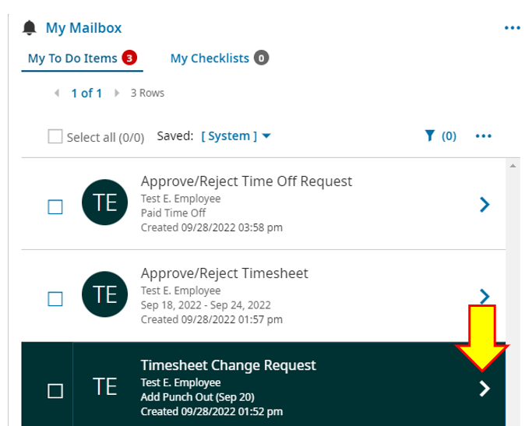
  - The detail will tell you
    - The type of change:
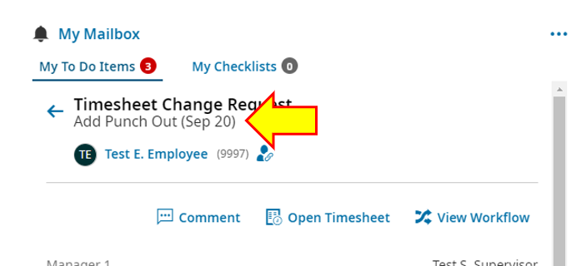
    - Click on the “Comment” to see the comment the employee attached
      - Click the “X” when done
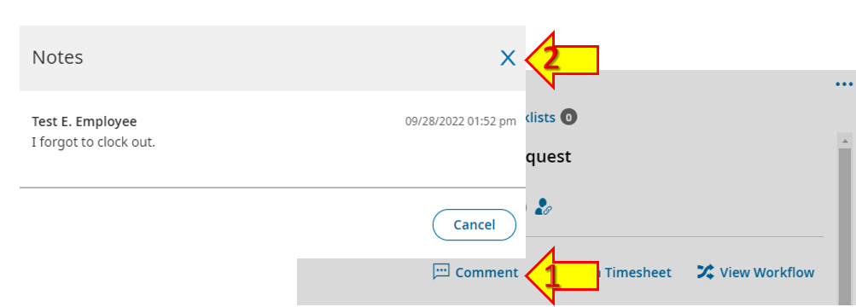
    - You can jump straight to the timecard to view it from this screen as well:
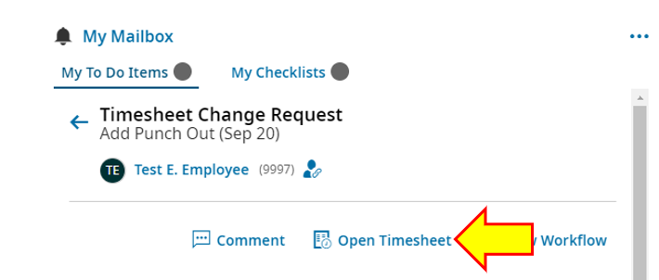

      - Click the “back arrow” on the timecard to return to the request when you are done
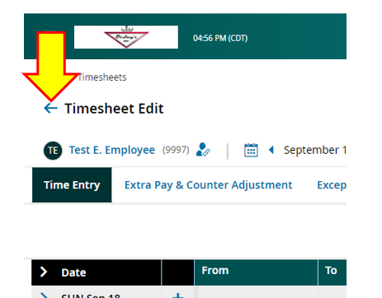
    - Scroll to the bottom to see what day, and the requested “out” time to add to the timecard
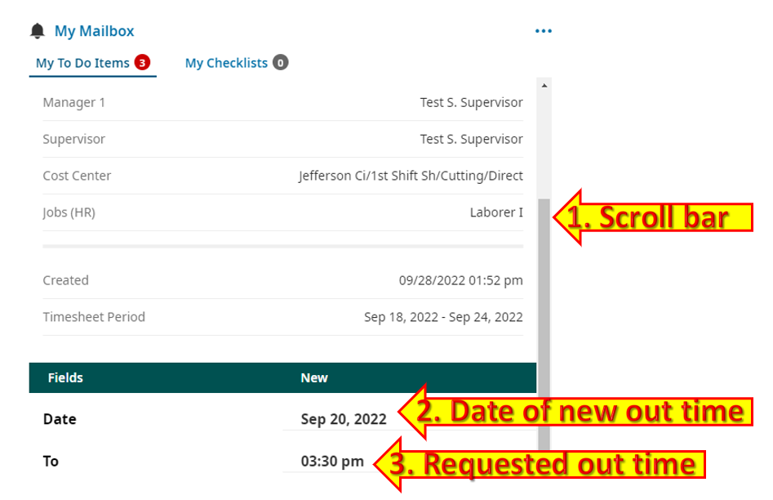
  - Once reviewed, click “Approve” or “Reject” at the bottom of this detail screen:
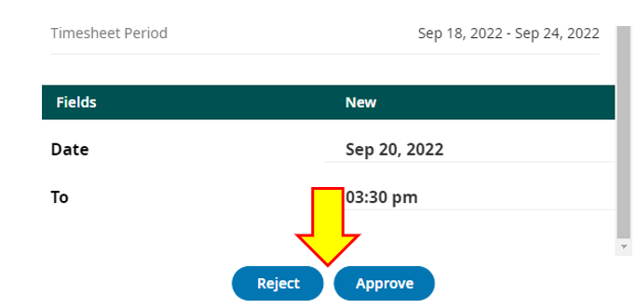

- Once timecards are submitted, review them before approving.
  - From your dashboard, go to the “Timesheets Awaiting My Approval widget.
    - Click the box in the green bar to select all submitted timesheets
    - Then click “View”
    - This will allow you to click through all submitted timecards without changing screens.
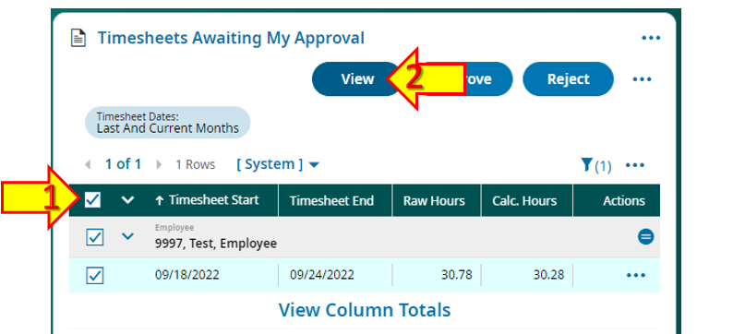

  - Review each timecard for errors
    - MOST IMPORTANT: LOOK FOR ERRORS MARKED WITH COLOR!
    - Absences, tardies, and early quits will show up marked this way.
    - Most of these need to be fixed BEFORE you approve the timecard.
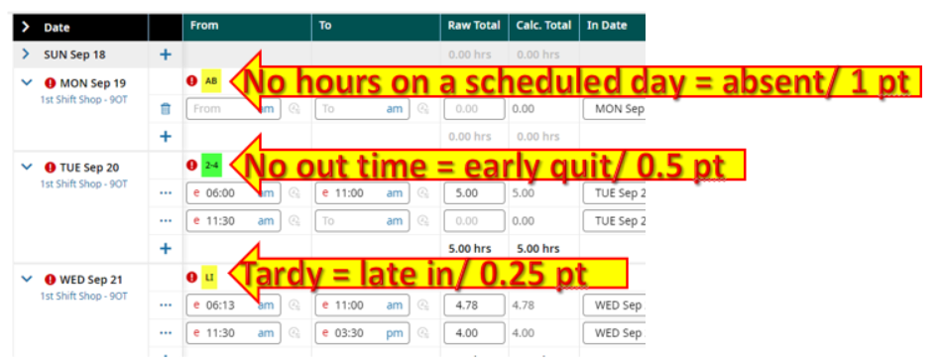
    - Having an incorrect schedule can be the cause of a lot of tardies/early quits.
      - These need to be fixed BEFORE the timecard is approved.
      - You can change that from the timecard by clicking on the blue schedule link on any given day:
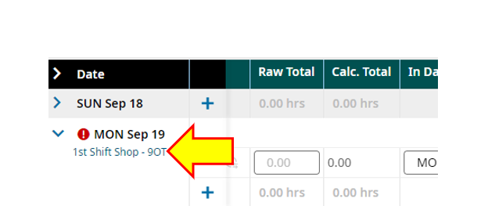

        - Use the drop-down menu to select the correct schedule and click save
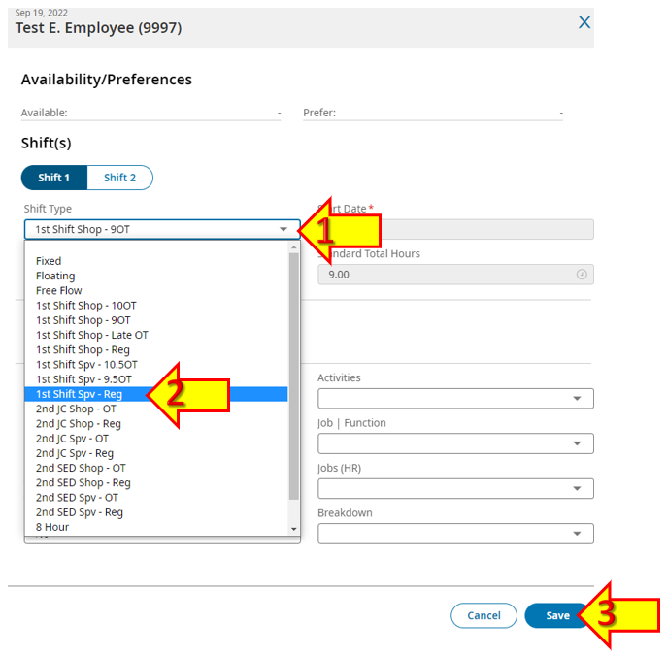
      - Contact HR to make more permanent schedule changes or to get any help at all with schedules.

  - Next, look at the Job/Function column.
    - Since job/function are paired, you won’t have to check that anymore.
    - You do need to make sure the correct job/function was selected.
    - The ONLY time it is okay for this to be blank is if it is on a leave line. Any worked hours MUST have a job/function:
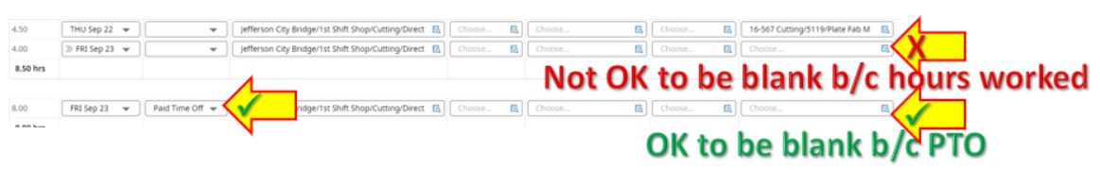
    - Employees CAN edit this part of their timecard.

  - If the timesheet is accurate and free of errors, you can click “Approve” and click forward to the next submitted timesheet to review.
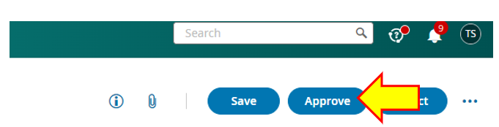

  - If there are errors on the timecard, you can either correct them, or use the “Reject” button to send it back to the employee.
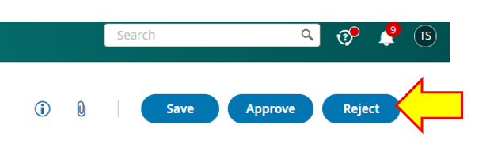
    - Please use the comment section to tell the employee why it is rejected!
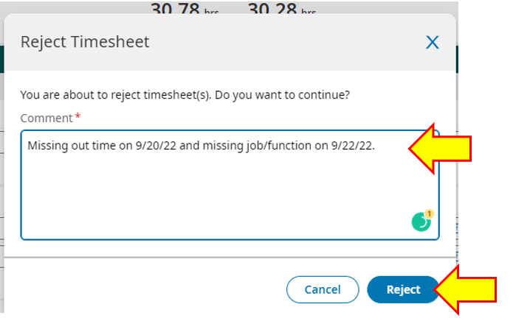
    - This will move the timesheet back to “Open” status so the employee can take necessary action.

My Saved Reports
- Important real-time reports will live here for you to view at any time.
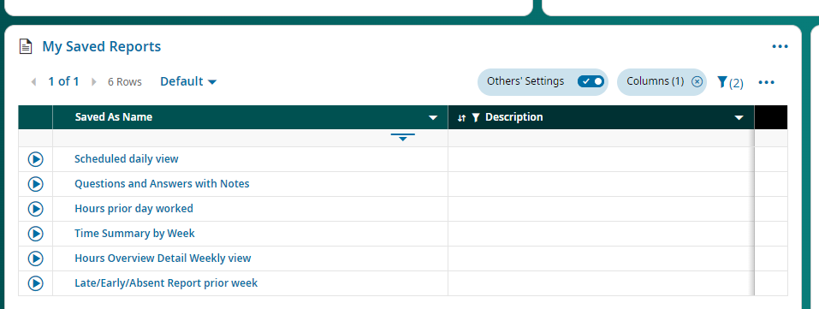
  - Scheduled daily view
    - Shows the schedule to which your employees are assigned
    - Good idea to audit on Mondays to make sure their week will be accurate
  - Prior Day worked job/function
    - Will show the job/function employees clocked into the day before
    - Auditing regularly will reduce time on Monday’s.
  - Open Timesheets
    - Will show any timesheets that have not been submitted.
    - Will be useful to check after 9:00 AM break on Mondays to remind EE’s to review/submit.

